Assginment 5 :

**Download and read the Olympic.csv into R :**

Data Set Description

The data set consists of the following fields:

Athlete​: Name of the athlete

Age​: Age of the athlete

Country​: The name of the country participating in Olympics

Year​: The year in which Olympics is conducted

Closing​ Date​: Closing date of Olympics

Sport​: Sports name

Gold Medals​: No. of gold medals

Silver Medals​: No. of silver medals

Bronze Medals​: No. of bronze medals

Total Medals​: Total no. of medals

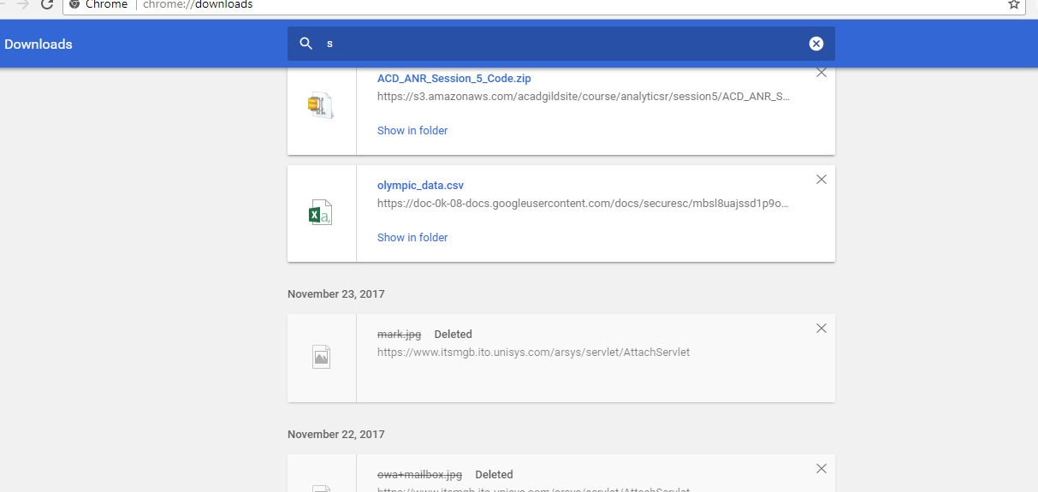

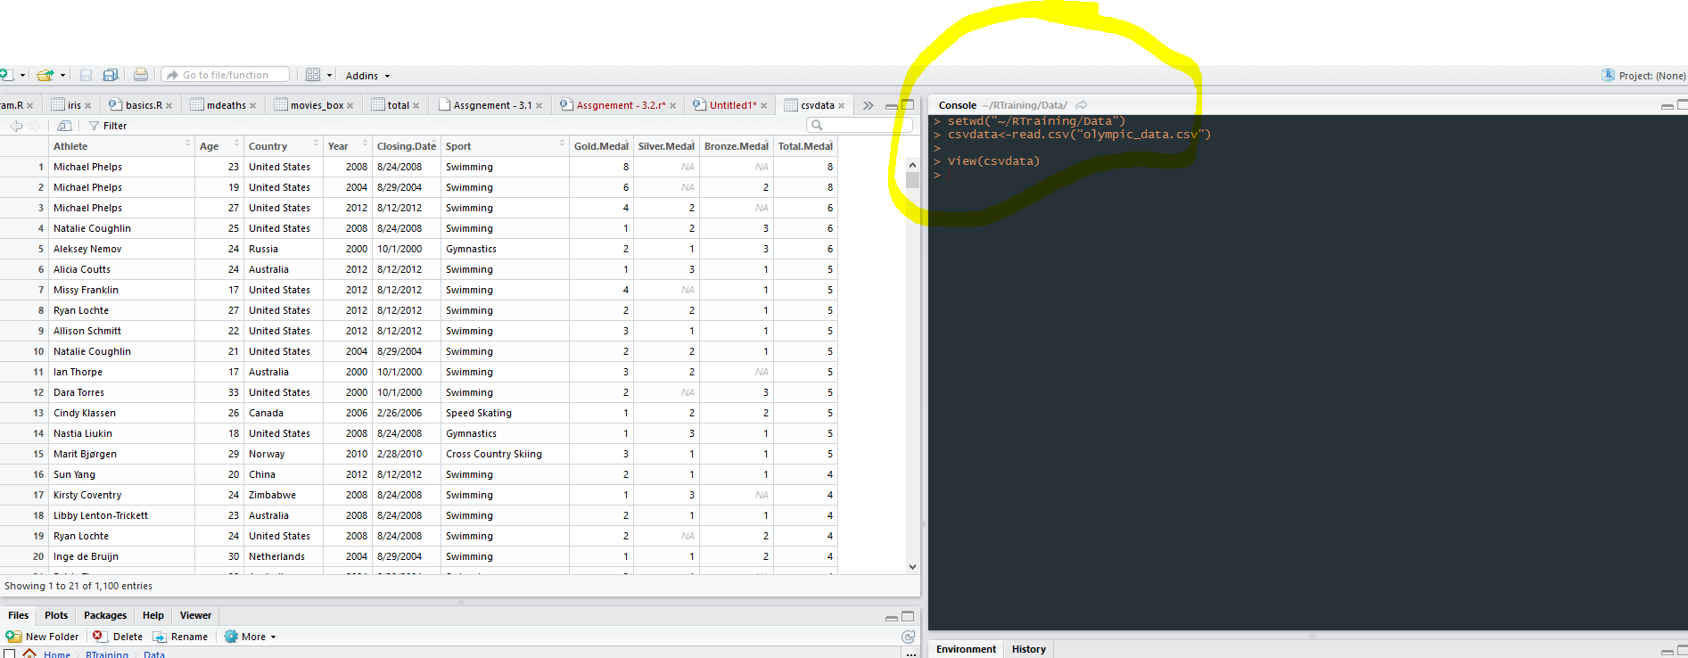

1. Consider only those participants who have all the data points

AnS :

Code Till Here

setwd("~/RTraining/Data")

csvdata<-read.csv("olympic_data.csv")

View(csvdata)

csvdt2<-na.omit(csvdata)

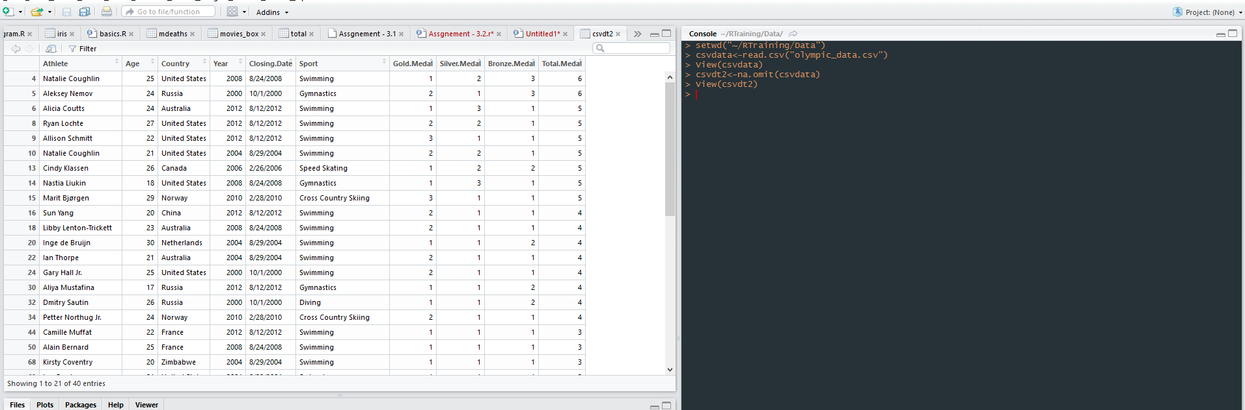

Q 2 - 2. Rank the participants in terms : • Swimming • Table Tennis • Shooting • Gymnastics • Total

Medal

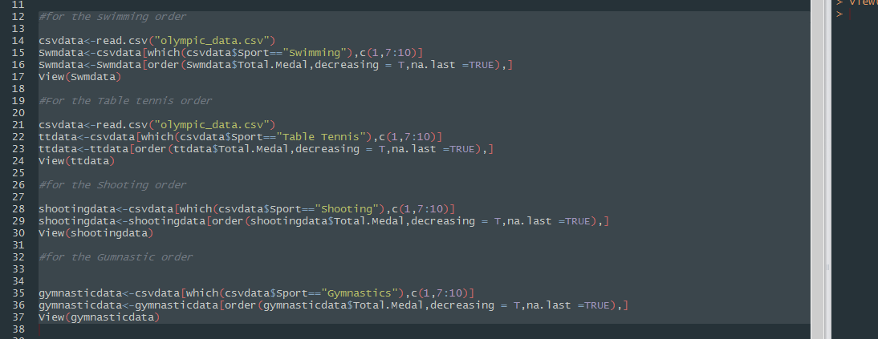

Code for Question 2

#for the swimming order

csvdata<-read.csv("olympic_data.csv")

Swmdata<-csvdata[which(csvdata$Sport=="Swimming"),c(1,7:10)]

Swmdata<-Swmdata[order(Swmdata$Total.Medal,decreasing = T,na.last =TRUE),]

View(Swmdata)

#For the Table tennis order

csvdata<-read.csv("olympic_data.csv")

ttdata<-csvdata[which(csvdata$Sport=="Table Tennis"),c(1,7:10)]

ttdata<-ttdata[order(ttdata$Total.Medal,decreasing = T,na.last =TRUE),]

View(ttdata)

#for the Shooting order

shootingdata<-csvdata[which(csvdata$Sport=="Shooting"),c(1,7:10)]

shootingdata<-shootingdata[order(shootingdata$Total.Medal,decreasing = T,na.last =TRUE),]

View(shootingdata)

#for the Gumnastic order

gymnasticdata<-csvdata[which(csvdata$Sport=="Gymnastics"),c(1,7:10)]

gymnasticdata<-gymnasticdata[order(gymnasticdata$Total.Medal,decreasing = T,na.last =TRUE),]

View(gymnasticdata)

Q3 –. Rank the Categories in terms of Age.(Higher the Age,Higher the Rank)

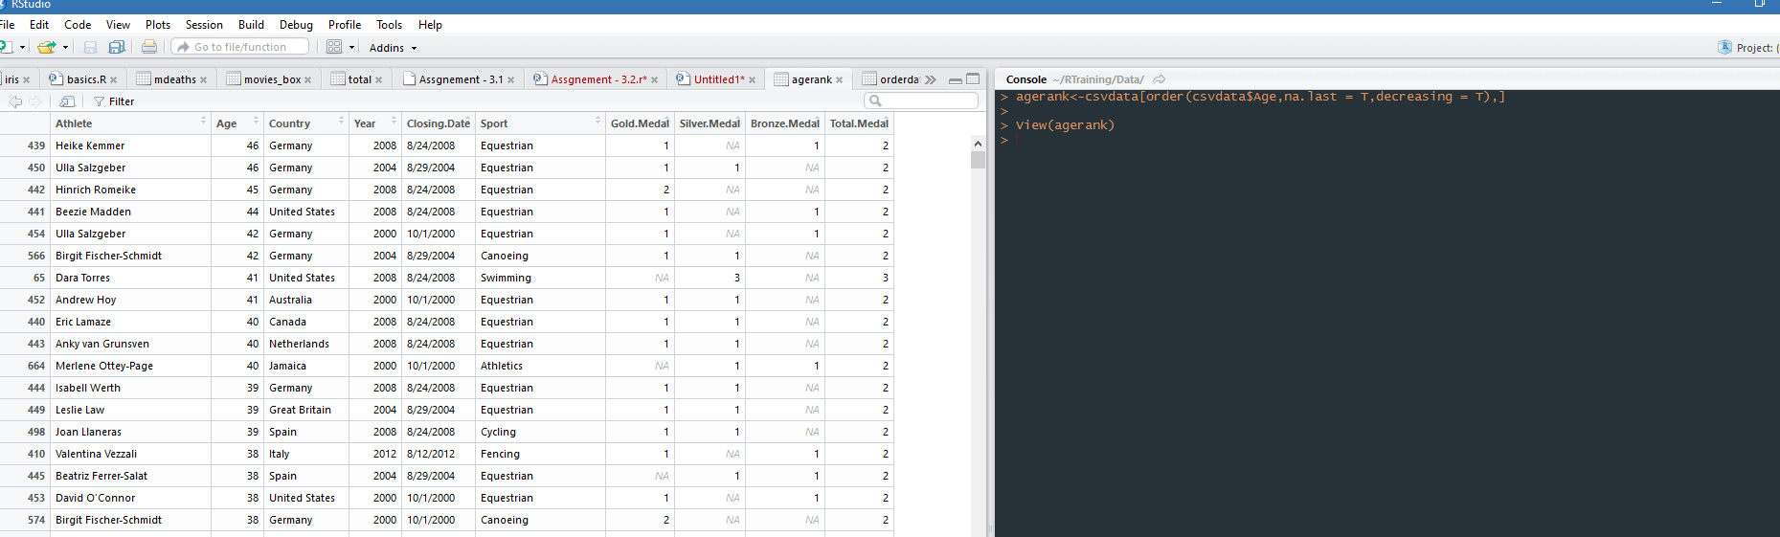

Code for Question 3 -

agerank<-csvdata[order(csvdata$Age,na.last = T,decreasing = T),]

View(agerank)

Q 4-. Identify Year wise top participants in terms of : • Swimming • Table Tennis • Shooting •

Gymnastics • Total Medal

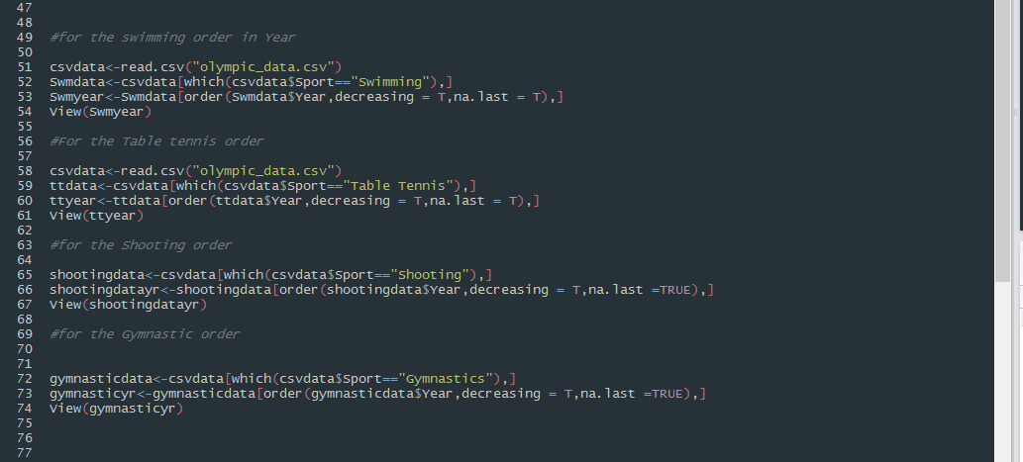

Code for Question 4

csvdata<-read.csv("olympic_data.csv")

Swmdata<-csvdata[which(csvdata$Sport=="Swimming"),]

Swmyear<-Swmdata[order(Swmdata$Year,decreasing = T,na.last = T),]

View(Swmyear)

#For the Table tennis order

csvdata<-read.csv("olympic_data.csv")

ttdata<-csvdata[which(csvdata$Sport=="Table Tennis"),]

ttyear<-ttdata[order(ttdata$Year,decreasing = T,na.last = T),]

View(ttyear)

#for the Shooting order

shootingdata<-csvdata[which(csvdata$Sport=="Shooting"),]

shootingdatayr<-shootingdata[order(shootingdata$Year,decreasing = T,na.last =TRUE),]

View(shootingdatayr)

#for the Gymnastic order

gymnasticdata<-csvdata[which(csvdata$Sport=="Gymnastics"),]

gymnasticyr<-gymnasticdata[order(gymnasticdata$Year,decreasing = T,na.last =TRUE),]

View(gymnasticyr)